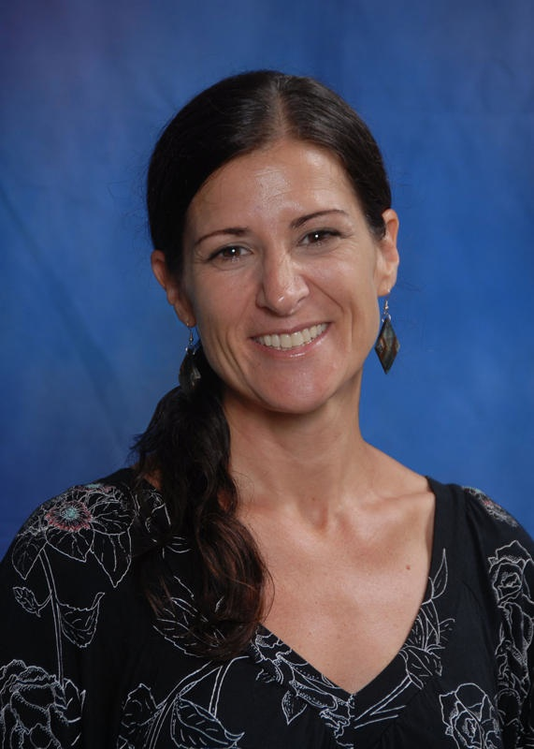
Valerie D. Rosen
10a Avenida 5-05, zona 14,
Condominio Capuchinas, Casa 2
Guatemala City, Guatemala 01014
Email: ganbatte1967@yahoo.com
Professional Website: http://vrosen.webnode.com
Canadian Citizen

PROFESSIONAL OBJECTIVE
To teach English and Digital Photography at the secondary level and to collaborate
with professional teaching colleagues in a 21st century international academic setting.

EDUCATION
( June 1996) M.S. Instructional Leadership in Curriculum and Instruction;
National University, San Diego, CA, USA.
(June 1994) Clear Multiple Subject Teaching Credential:
Supplementary Authorizations: English; Home Economics;
National University, San Diego, CA, USA.
(Aug. 1992) B.A. Applied Arts and Sciences - Home Economics;
San Diego State University, San Diego, CA, USA.

CERTIFICATION
(May 1998) Certificate of Gifted and Talented Instruction (G.A.T.E.);
San Diego City Schools District, San Diego, CA, USA
(Jan. 1994) Language Development Specialist Certification;
San Diego County Office of Education, San Diego, CA, USA.

SPECIAL SKILLS
I am fluent in French and have an intermediate ability in Spanish, and Japanese.
In addition, I am proficient in Microsoft Word, Excel, PowerPoint, and Publisher, as well as,
in Grade Quick and Easy Grade Pro grading programs.
I also have substantial experience in using Edline, Moodle, and Webnode webpage programs.

EXPERIENCE
(Aug. 2009 – Present) Teacher of American Literature (11) & Digital Photography (11-12): Colegio Interamericano, Guatemala City, Guatemala. Duties include: Teaching 100% of the 11th grade ESL student population (75 students) in American Literature (in accordance with California 11th Grade Curriculum Standards); Designing and Implementing an Essential Questions-driven year-long curriculum for 11th – 12 th Grade Digital Photography Exploratory Course (20 students); Advising yearbook student photographers.

(July 2007 - June 2009) Teacher English Language Arts (8); Colegio Interamericano, Guatemala City, Guatemala. Duties included: Teaching 100 % of the 8th Grade ESL student population (80 students) in the areas of Literature and Language Arts; Advising MS Community Service Club, MS French Club, and the MS Photography Club.

(Aug. 2006 - June 2007) Teacher of English Language Arts (8); Korea International School, Bundang, Korea Rep. Duties include: Teaching 100% of the 8th Grade student population (80 students) in the areas of Literature and Language Arts; Advising MS Student Council of 15 members; Teaching a semester exploratory course of Digital Photography to 6th-8th grade students.

(Nov. 2004 – July 2006) Teacher of Speaking & Listening (ESL), Reading & Writing (ESL), Public Speaking (college entry level), American Culture (ESL high school level), American Literature (college entry level; Human International Universities and Colleges Consortium (HIUC). Duties included: Teaching academic skills in an accelerated English language program to Japanese high school graduates; Preparing and creating teaching materials to support ESL learning needs geared toward T.O.E.F.L. proficiency testing in the areas of Reading, Writing, Speaking and Listening; Teaching standard college entry level
Public Speaking and American Literature Seminar courses.

(Aug. 2002 – July 2004) EFL Teacher; Aeon East Japan, Osaka, Japan. Duties included; Teaching English grammar and conversation to students ranging in age of 16-65 and of low to high language ability levels in private, small and large groups of up to 8 in number; Counseling all students toward meeting educational goals on a regular basis; Visited companies
as on-site teacher of business English, grammar and conversation.

(Sept. 1994 – June 2002) Teacher of English Literature/Language Arts(7), Social Studies(7), Journalism(7-8), Public Speaking(8), and Consumer & Family Studies(6-8); Taft Middle School, San Diego, CA, USA. Duties included: Teaching all areas of the English Language, such as English language conventions, English Literature, World History and Cultures, Speech writing and presentation, Journalism, Cooking, Nutrition & Consumer Studies; Advising students on design and production of school newspaper and school yearbook; Organizing school-wide annual spelling bees; Handling parent conferences and maintaining consistent communication regarding students’ educational needs.

EXTRACURRICULAR ACTIVITIES
More recently in Guatemala, I have designed and implemented a full year’s curriculum for a high school Digital Photography elective class, as well as, advised the yearbook photographers. In past years, I have coordinated school-wide spelling bees at the middle school level, as well as organized evening field trips to the Opera. Also, I have advised a student philanthropic group, called “Students Who Care” (SWC) in fund-raising activities on site, and volunteer efforts within the local community.

HONORS AND AWARDS
“San Diego Hats off to Teachers” Award nomination by Principal (1996)
“Teacher of the Year” Award nominations by colleagues (2000, 2001)

PROFESSIONAL ORGANIZATIONS
National Council for Teachers of English (NCTE) membership (1998-2002)

TRAVEL
I have visited 19 countries, including; England, Scotland, France, Barbados, Malaysia, Thailand, Cambodia, Laos, China, Vietnam, Mexico, Cuba, Honduras, El Salvador, Peru, Bolivia, Chile, Argentina, and Uruguay, and I have lived in 4 countries outside of Canada, including; America, Japan, S. Korea, and Guatemala, where I currently reside. This holiday season, I will visit Panama, Ecuador, Colombia, and Venezuela.

PERSONAL
In the last year, I have been developing experience as a freelance photographer online and locally. In addition, travel and scuba diving (advanced certified with over 50 dives logged) are also great personal passions. I’m drawn to all areas of the Visual and Performing Arts, including; international theater, music, art, and film. I enjoy a range of hobbies, such as: yoga; hiking/trekking; downhill skiing; kayaking; cooking and reading.

REFERENCES

Jeff Trudeau, Assistant General Director/HS Principal
Colegio Interamericano
Guatemala City, Guatemala
Aug. 2010-Present
Tel: (work) 502-2385-7088 (home) 502 -5016-9685

Victor Ramirez, Vice-Principal
Colegio Interamericano
Guatemala City, Guatemala
July 2007-Present
Tel: (work) 502-2385-7088 (home) 502-2354-1779
vramirez@interamericano.edu.gt

Dr. Michael Farr, Retired
(Former General Director of Colegio Interamericano)
Guatemala City, Guatemala
July 2007- June 2010
Tel: 502-2354-1779
robertmfarr@msn.com

Richard Boerner, Superintendent
American International School/Dhaka
Aug 2006 – June 2007
Phone: (880-2) 882-2452
boerner@ais-dhaka.net

